Test Report: Random Date Generator

# Goal:

To spend an hour exploring the Random Date Generator (RDG) app at <https://codebeautify.org/generate-random-date>.

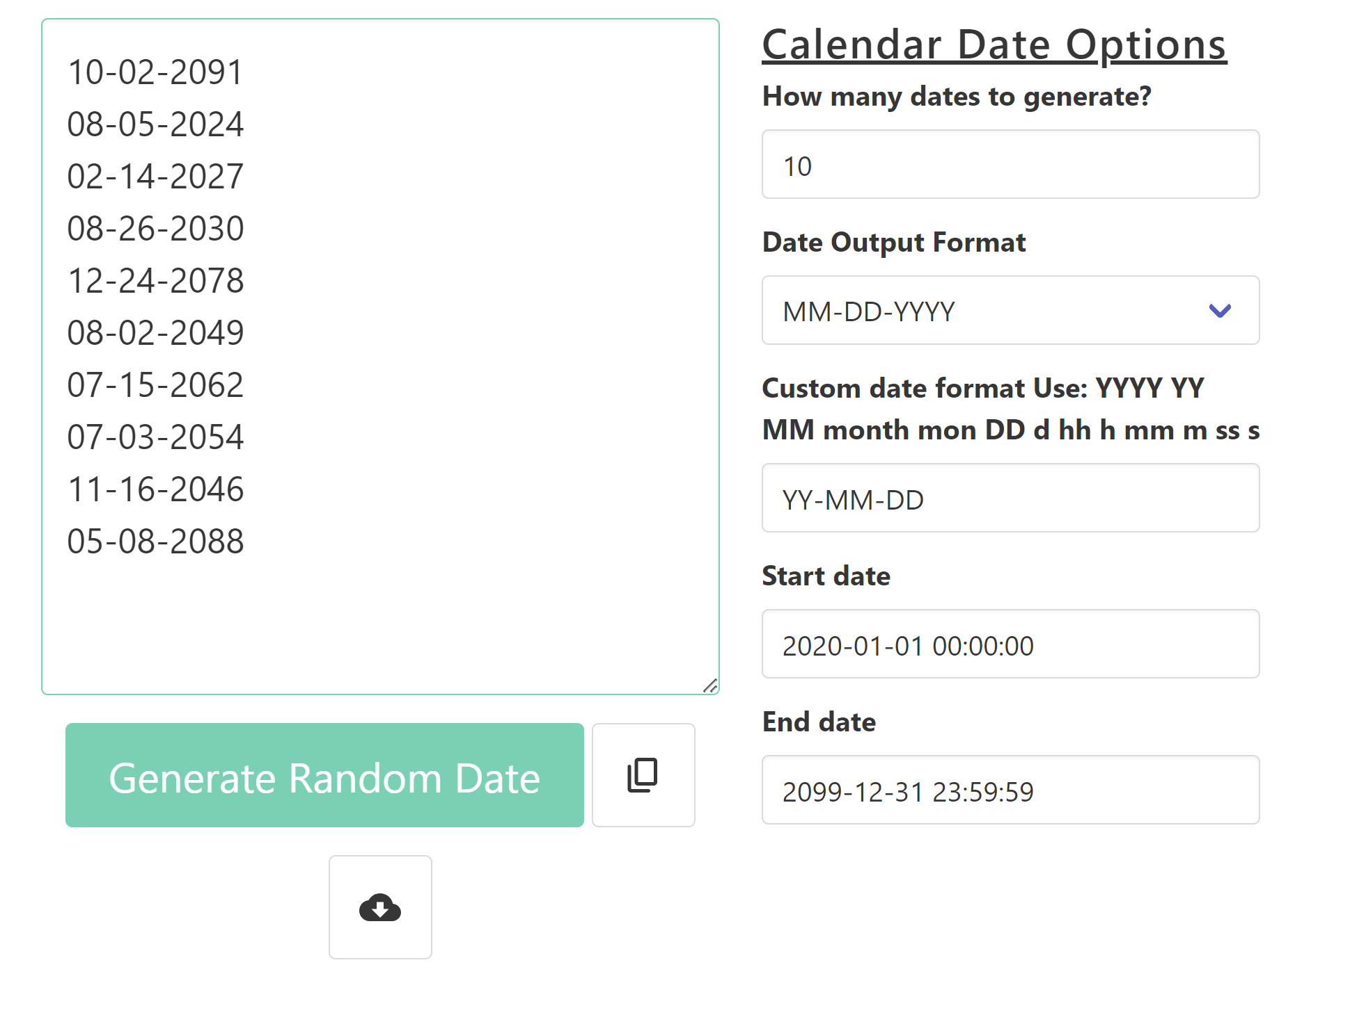

# Methodology

Due to the limited time available, the testing focused on simple smoke tests for most of the functionality, with more in-depth testing when issues were discovered.

# Environments

The RDG app claims it “*works well on Windows, MAC, Linux, Chrome, Firefox, Edge, and Safari*”. Due to time limits, only Windows11 with Chrome was used for this testing session.

# Testing

1. All results when generating a date:
   1. Correctly formatted
   2. Correct data
      1. Within Start/End dates
2. Formats
   1. Each of the supported preset formats.
3. Inputs
   1. Default options
   2. Number of Dates (Count)
      1. Boundary -1, 0, 1, max-1, max, max+1
      2. Non-integer (string, decimal/float)
   3. Start/End Dates
      1. Default
      2. Start & End on same day w/ different times (0000-2359, 0000-0001), same day w/ same time (1345-1345)
      3. End before Start (day, time)
      4. Valid date/time, but not datetime format yyyy-mm-dd hh:mm:ss
      5. Non-valid entries
   4. Custom date format
      1. Custom (From RDG: YYYY YY MM month mon DD d hh h mm m ss s)
4. Download file
   1. 0 dates, 10 dates, many dates
   2. File downloaded with displayed results
5. Copy Results button
   1. 0 dates, 10 dates, many dates
   2. Copy includes match displayed results
6. Usability
   1. Spelling/Grammar
   2. Helpful & Complete Help/Instructions
7. Appearance
8. Controls
   1. Buttons - Generate Random Date, Copy, Download
   2. Fields - Integer picker, dropdown, text
   3. Results expander

*Unable to perform due to limited time*

1. Different Browser Locales, Browser Languages, Time Zones
2. Accessibility
   1. Tab order, keyboard only, audio reader, resolution
3. Environments (OS & Browsers)
   1. Windows, MacOS, Linux, Android, iOS
   2. Chrome, Firefox, Safari, Edge, etc.

# Results

Due to the issues discovered, this is not currently not ready for release. Additional testing should be performed, especially with different browsers and operating systems.

### Issues Discovered:

1. Results can be outside of start/end date range when using ISO 8601 format (Bug #1)
2. Year Date Month format outputs incorrect format (year month date) (Bug #2)
3. Custom Date Format’s ‘month’ results display values instead of the letters for h,y,m (Bug #3)
4. Custom Date Format’s lowercase ‘m’ is incorrectly displaying in results (Bug #4)
5. Count field is not restrained to acceptable values (Bug #5)
6. Start date can be before End Date; results will not include either the start or end datetimes. (Bug #x)
7. Standardize app name to a single string (currently ‘Random Date Generator’, ‘Date Generator’ and ‘Random Date Generator Online’). (Bug #x)
8. Strings should be edited to improve clarity and fix grammatical errors. (Bug #x)